

Bike renting

VIMAL KUMAR K



July 25, 2019

Vimal.k0007@gmail.com

**Contents**

**1. Introduction**

1.1 Problem Statement . . . . . . . . . . . . . . . . . . . . . . . . . . . . . . . . . . . . . . . . . . 4

1.2 Data . . . . . . . . . . . . . . . . . . . . . . . . . . . . . . . . . . . . . . . . . . . . . . . . . . . . . . 4

1.3 Exploratory Data Analysis . . . . . . . . . . . . . . . . . . . . . . . . . . . . . . . . . . . . . 5

**2. Methodology**

2.1 Data exploration . . . . . . . . . . . . . . . . . . . . . . . . . . . . . . . . .. . . . . .. . . .. . 7

2.2 Pre-Processing . . . . . . . . . . . . . . . . . . . . . . . . . . . . . . . . . . . . . . . . . . . . . . 7

2.2.1 Missing Value Analysis . . . . . . . . . . . . . . . . . . . . . . . . . . . . . . . . . . . .. . .7

2.2.2 Outlier Analysis . . . . . . . . . . . . . . . . . . . . . . . . . . . . . . . . . . . . . . . . . . .. 8

2.2.3 Feature Selection . . . . . . . . . . . . . . . . . . . . . . . . . . . . . . . . . . . . . . . . . .. 10

2.2.4 Feature Scaling . . . . . . . . . . . . . . . . . . . . . . . . . . . . . . . . . . . . . . . . . . .. 13

**3. Modeling**

3.1 Machine learning algorithm . . . . . . . . . . . . . . . . . . . . . . . . . . . . . . .. . .. .14

3.2 Model selection. . . . . . . . . . . . . . . . . . . . . . . . . . . . . . . . . .. .. . . . . . . .. . . 14

3.2.1 Decision Tree. . . . . . . . . . . . . . . . . . . . . . . . . . . . . . . . . . . . . . . . . . . . . 15

3.2.2 Random Forest . . . . . . . . . . . . . . . . . . . . . . . . . . . . . . . . . . . . . . . . . . . .15

3.2.3 Linear Regression . . . . . . . . . . . . . . . . . . . . . . . . . . . . . . . . . . . . . . . . . 15

**4. Conclusion**

4.1 Model Evaluation . . . . . . . . . . . . . . . . . . . . . . . . . . . . . . . . . . . . . . . . . . . 17

4.1.1 MAPE (mean absolute percentage error) . . . . . . . . . . . . . . . . . . . . . 17

4.2 END NOTE . . . . . . . . . . . . . . . . . . . . . . . . . . . . . . . . . . . . . . . . . . . . . . . . . .21

**Appendix A**

VIF. . . . . . . . . . . . . . . . . . . . . . . . . . . . . . . . . . . . . . . . . . . . . 19

Basic Output terms . . . . . . . . . . . . . . . . . . . . . . . . . . . . . . .19

**Appendix B**

References. . . . . . . . . . . . . . . . . . . . . . . . . . . . . . . . . . . . .21

***LIST OF FIGURES***

Page no

**1.1.** Boxplots of outliers………………………………………………………….…………………..8

**2.1.** Correlation plot……………………………………………………………………………………12

***LIST OF TABLES***

Page no.

* 1. Sample data (column 1:9)…………………………………………………………………5
  2. Sample data (column 10:16)……………………………………………………………….6

**2.1**. ANOVA for categorical variable……………………………………………………….11

**3.1** Decision Tree accuracy table……………………………………………………………15

**3.2** Random Forest accuracy table…………………………………………………………15

**3.3** Linear Regression accuracy table……………………………………………………..16

**3.4** Accuracy of the models........................................................................16

**ABSTRACT**

A bike rental or bike hire business rents out [bicycles](https://en.wikipedia.org/wiki/Bicycle) for short periods of time, usually for a few hours. Most rentals are provided by bike shops as a sideline to their main businesses of sales and service, but some shops specialize in rentals. In this project XYZ bike renting company severe issue of bike demand and supply has shared its dataset which contains the information about the user of that company of certain period of time. On the basis of the give dataset and observed pattern and insights we have to predict the future value and help them to know the factors which help them to balance supply and demand of the Rental bikes.

We are using both R and Python to build the suitable model according to the company’s problem statement. We will try different ML Algorithm and will choose the best model accordingly to help them to know the answers for the questions mentioned above.

**Chapter 1**

**Introduction**

* 1. **Problem Statement**

The objective of this case is to predict the number of bikes rent count based on the environment and seasonal setting i.e. the total number of people renting the bike on the daily basis.  
  
**1.2 Data**

There are 16 variables in our data in which 15 are independent variables and 1 (cnt) is dependent variable. Since our target variable is continuous in nature, this is a regression problem.

**Variable information:**

1. Instant: Record index
2. dteday: Date
3. season: Season (1: springer, 2:summer, 3:fall, 4:winter)
4. yr: Year (0: 2011, 1:2012)
5. mnth: Month (1 to 12)
6. holiday: weather day is holiday or not (extracted fromHoliday Schedule)
7. weekday: Day of the week
8. workingday: If day is neither weekend nor holiday is 1, otherwise is 0.
9. weathersit: (extracted fromFreemeteo)

* 1: Clear, Few clouds, Partly cloudy, Partly cloudy
* 2: Mist + Cloudy, Mist + Broken clouds, Mist + Few clouds, Mist
* 3: Light Snow, Light Rain + Thunderstorm + Scattered clouds, Light Rain + Scattered
* clouds
* 4: Heavy Rain + Ice Pallets + Thunderstorm + Mist, Snow + Fog

1. temp: Normalized temperature in Celsius. The values are derived via (t-t_min)/(t_max-t_min), t_min=-8, t_max=+39 (only in hourly scale)
2. atemp: Normalized feeling temperature in Celsius. The values are derived via (t-t_min)/(t_max-t_min), t_min=-16, t_max=+50 (only in hourly scale)
3. hum: Normalized humidity. The values are divided to 100 (max)
4. windspeed: Normalized wind speed. The values are divided to 67 (max)
5. casual: count of casual users
6. registered: count of registered users
7. cnt: count of total rental bikes including both casual and registered

**1.3 Exploratory Data Analysis**

Exploratory Data Analysis (EDA) is an approach to analyzing data sets to summarize their main characteristics and differentiate the categorical and continuous variables and understand the data better for our analysis. In the given data set there are 16 variables in which 1 to 15 are independent variable and 16th variable (cnt) is our target variable and data types of all variables are either float64 , int64 and objet(date). There are 731 observations and 16 columns in our data set. No Missing value is also present in our data.

**List of columns and their number of unique values** -

* instant 731
* dteday 731
* season 4
* yr 2
* mnth 12
* holiday 2
* weekday 7
* workingday 2
* weathersit 3
* temp 499
* atemp 690
* hum 595
* windspeed 650
* casual 606
* registered 679
* cnt 696

**From EDA we have concluded that there are 9 continuous variable and 7 categorical variables in nature.**

**Table 1.1** represents the sample of the dataset on which we applied the preprocessing techniques and algorithms for further prediction of the target class.

**Table 1.1:** Sample ofBike rental Dataset (Column 1 to 9)

|  |  |  |  |  |  |  |  |  |
| --- | --- | --- | --- | --- | --- | --- | --- | --- |
| **instant** | **dteday** | **season** | **yr** | **mnth** | **holiday** | **weekday** | **workingday** | **weathersit** |
| 1 | 01-01-2011 | 1 | 0 | 1 | 0 | 6 | 0 | 2 |
| 2 | 02-01-2011 | 1 | 0 | 1 | 0 | 0 | 0 | 2 |
| 3 | 03-01-2011 | 1 | 0 | 1 | 0 | 1 | 1 | 1 |
| 4 | 04-01-2011 | 1 | 0 | 1 | 0 | 2 | 1 | 1 |
| 5 | 05-01-2011 | 1 | 0 | 1 | 0 | 3 | 1 | 1 |

**Table 1.2:** Sample of Employee Absenteeism Dataset (Column 10 to16)

|  |  |  |  |  |  |  |
| --- | --- | --- | --- | --- | --- | --- |
| **temp** | **atemp** | **hum** | **windspeed** | **casual** | **registered** | **cnt** |
| 0.344167 | 0.363625 | 0.805833 | 0.160446 | 331 | 654 | 985 |
| 0.363478 | 0.353739 | 0.696087 | 0.248539 | 131 | 670 | 801 |
| 0.196364 | 0.189405 | 0.437273 | 0.248309 | 120 | 1229 | 1349 |
| 0.2 | 0.212122 | 0.590435 | 0.160296 | 108 | 1454 | 1562 |
| 0.226957 | 0.22927 | 0.436957 | 0.1869 | 82 | 1518 | 1600 |

**Chapter 2**

**Methodology**

We know that data is backbone of data science is Data. We collect data from different sources and converting data I proper format is very necessary. When any new project comes in we spend 80% time in understanding, cleaning and preparing the data as driving the data according to problem is very important. The whole data process is divided into six phases.

1. Business understanding: When any client comes in we should try to understand their problem statement first. It helps us to get proper data for better results.
2. Data understanding: In this we use many statistical techniques, Graphs and visualizations to understand the data so that we can understand the data well and can get relevant data from the client.
3. Data Preparation: This means exploring the raw data we receive from client and understanding what data speaks out. In data science 80% of our time goes in data understanding, cleaning and preparation and 20% in model development and model evaluation. If the quality of data is good the model will predict better and results in high accuracy.
4. Data modeling: There are many machine learning algorithms and we have to select the most appropriate algorithm according to our problem statement.

Evaluation: It helps us to evaluate our model. It tells us whether our model is able to accomplish the business objective or not.

1. Deployment: This is the final phase in which we deploy our model in client premises.

**2.1 Data Exploration**

In data exploration we try to understand the data. We should observe the data and understand them. Looking at data and understanding them with the help of different tools and graph and visualizations is called Exploratory Data Analysis. It is one of the very important steps as driving the data according to problem statement is very necessary and to drive the data, we need to understand our data first.

In our project we check the data type dimensions, shape of the data, and count of unique values in each variable. In our dataset we have 731 observations and 16 variables. All the variables are in numeric format. Later in preprocessing technique we changed some of the variables such as instant, temp, atemp, hum, windspeed, casual, registered and cnt are into numeric(continues) and season, yr, mnth, holiday, weekday, workingday and weathersit are into categorical and dteday as date format.

**2.2 Pre-Processing techniques**

Data preprocessing is a data mining technique that involves transforming raw data into proper format to feed the data to model. It prepares raw data for further processing. Data preprocessing includes cleaning, normalization, transformation, feature extraction and selection etc. The product of data preprocessing is final training set. Data we receive from client is messy data. If there is much irrelevant and redundant information present in our dataset it will make our model inconsistent which results in poor and low results.

**2.2.1 Missing value analysis**

Missing value is the values which are not present or missing from the dataset. Missing values appears in our dataset due to various reasons like human error, refuse to answer the questions in a survey or optional box questionnaire. The skipped or unanswered questions appear in form of missing values. Missing values can be treated either by dropping the variable or by imputing the missing values.

With the help of domain knowledge, we need to understand why there is missing value in a dataset and then it is suitable to know whether to ignore or impute the missing values.

**When to ignore the missing values:** First we will create a data frame which tells us amount of missing values present in each variable. Drop the variables which consists more than 30% (according to industry standards) of missing values.

**When to impute missing values and methods of imputation:** We will impute those variables whose missing percentage is less than 30%. There are three methods to impute missing values: **a)** Fill with central statistics method i.e. mean and median for continuous variable and mode (majority minority rule) for categorical variable. **b)** Distance based or Data mining method which includes KNN imputation. **c)** The last method is prediction method which is based on ML algorithms.

**We don’t have any missing value in the given dataset so no need to perform any action.**

**2.2.2 Outlier Analysis**

Outlier analysis is one of the preprocessing techniques used to check for abnormal values in the data set clean them and transform the data into a proper shape. There are many different techniques like Graphical Tools (Box Plot Method), Statistical technique (Grubbs test), R Package outlier for outlier analysis and replace with NA which will be treated as missing value analysis and will be imputed using suitable method mentioned in missing value analysis. Presence of outlier in our data leads to poor data quality and contamination, low quality measurement and manual errors. The best way to look at outlier is to understand business process i.e. how data is generated and how is the business flow.

We know that outlier analysis is applicable only on numerical variable so we have converted the entire variable in their appropriate data types and separated out numerical variables for outlier analysis. We have plotted box plot for each numerical variable which is shown below.

From the boxplot almost all the variables **except “hum”, “Windspeed” and “casual”** consists of outliers. Overall 59 outliers are present in data we have removed all the index or row in which outliers present considering clean data gives better prediction than impure data.

**Fig 1.1 Boxplot of outliers**

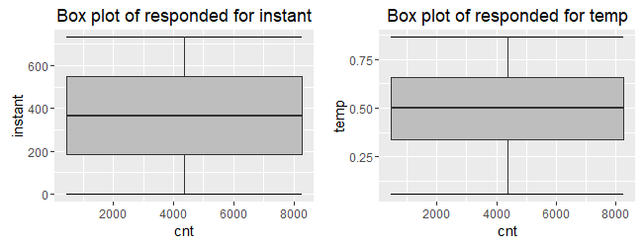

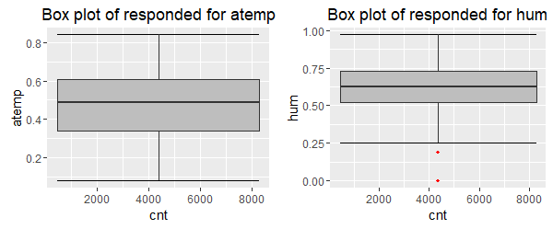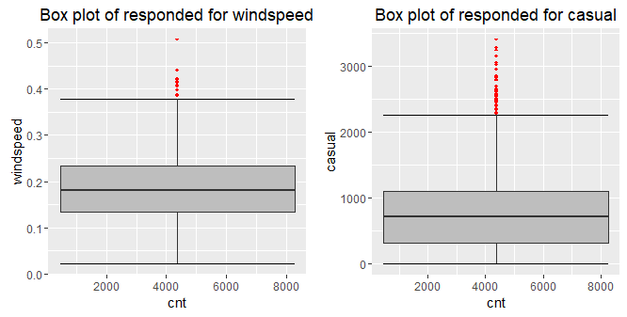

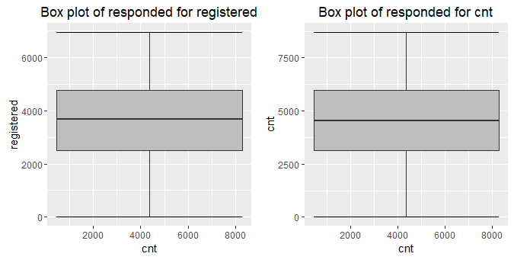

**2.2.3 Feature Selection**

Selecting subset of relevant features for model construction is known as Feature Selection. When we get raw data, we have multiple variables and with the help of variable selection we have to extract relevant data. We cannot use all the features because some features may be carrying the same information or irrelevant information which does not impact the business solution. To reduce complexity, we adopt feature selection technique to extract meaningful features out of it. This in turn helps us to avoid the problem of multi collinearity. Correlation Analysis (for numerical variable), Chi Square Test (for both target and predictor as categorical) and other ML algorithm like Random Forest are some of the methods of feature selection.

**Correlation analysis:** It is one of the methods for feature selection technique applied only on numerical data. Correlation tells us the association between two continuous variables. It ranges for -1 to +1.

**-1: Highly negatively correlated**

**0: No correlation**

**+1: Highly positively correlated**

In correlation there is an assumption that there should be high dependency between predictor and target variable but there should be low dependency between two predictors.

**ANOVA (Analysis of Variance):** It is applied on one categorical and one continuous variable. It is a statistical technique used to compare means of two or more group. We get results in form of p values. If p value is less than 0.05 we will reject NULL HYPOTHESIS (result purely from chance) and accepts ALTERNATE HYPOTHESIS (influenced by some non-random cause).

In our project we have used Correlation plot and ANOVA to select important variables and selected the variables according to the values of correlation and ANOVA. The correlation plot and ANOVA values are given below.

**Fig 2.1 ANOVA for categorical variable**

|  | **sum_sq** | **Df** | **F** | **PR(>F)** |
| --- | --- | --- | --- | --- |
| **season** | 5.709013e+07 | 3.0 | 29.483663 | 6.975031e-18 |
| **yr** | 6.919292e+08 | 1.0 | 1072.021097 | 1.013087e-139 |
| **mnth** | 1.423032e+08 | 11.0 | 20.043045 | 5.055421e-35 |
| **holiday** | 1.313346e+06 | 1.0 | 2.034795 | 1.542143e-01 |
| **weekday** | 7.823845e+06 | 6.0 | 2.020276 | 6.092876e-02 |
| **workingday** | 2.690534e+07 | 1.0 | 41.685028 | 2.097196e-10 |
| **weathersit** | 1.777184e+08 | 2.0 | 137.671524 | 1.368913e-50 |
| **Residual** | 4.201838e+08 | 651.0 | 2.737 | 1.655454e-50 |

**Fig 2.1:** Correlation between the variables

From correlation analysis we have found that **temp** and **atemp** has highly correlation (>0.7), so we have excluded the **temp** column. Also, **casual**, **registered** and **cnt** are positively correlated, so we have dropped **temp, casual** and **registered.**

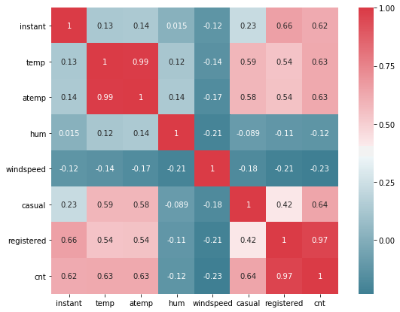

**4.3 Variance Inflation Factor(VIF) :** We have performed VIF test using function VIF which is used to check whether variables have multicollinearity .

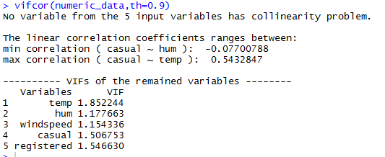

**4.3 Summary of Feature Selection:**

Conclusions from the various test has been drawn that **temp** and **atemp** are highly correlated so we have to drop any one and. Also, **casual**, **registered** and **cnt** are positively correlated so need to drop variable. As **dteday** and **instant** variables plays no role in our analysis we drop that variables also.

* + 1. **Feature Scaling**

It comes into an action when we are dealing with parameters of different units and scales. It is also known as variable scaling. It is used to limit the range of range of variables so that they can be compared on common basis. Feature scaling is performed only on continuous data. There are two methods to scale the data **Normalization and Standardization.** Normalization is the process of reducing unwanted variation either within or between variables. Normalization brings all the variables into proportion with one another. It ranges between **0 and 1** and are sensitive to outliers. Normalization works on all kind of continuous data whereas standardization works well when data is uniformly distributed.

In our project data is already scaled so no need to perform any action.

**Chapter 3**

**MODELING**

Data modeling means selecting appropriate ML (Machine Learning) Algorithm according to our problem statement. There are more than 100 algorithm and we need to select an appropriate one.

**3.1 MACHINE LEARNING ALGORITHM**

Machine Learning means programming computers to optimize a performance criterion using example data or past experience. With help of historical data, we try to extract patterns and save it in ML itself. Once a new test case comes in, we use that historical pattern to apply on new data to predict its class level.

**3.2 MODEL SELECTION**

There is multiple parameter based on which we select an algorithm to be developed for particular dataset.

1. It depends on problem statement as once we define problem statement then only, we will be able to find out which type of problem statement it is.
2. Every ML Algorithm has three components: **Representation, Evaluation and Optimization.** Some algorithm deliver output in form of business rules some in form of numbers, probability and visualizations.

It depends on client requirement that in which form they want the output. If they want output in form numbers then we will go for regression algorithms.

In our early stages of analysis during pre-processing we have come to understand the customer behavior pattern on test data. Here in our case the dependent variable “Absenteeism time in hours” is continuous in nature.

If the dependent variable is categorical the only predictive analysis that we can perform is **Classification** and if the dependent variable is Interval or Ratio i.e. continuous the normal method is to do a **Regression** analysis or classification after binning. The dependent variable we are dealing with is Regression, for which regression is preferred according to problem statement. We should always start our model building from the simplest to more complex. Here we have used different ML Algorithm on trained data and then applied it on test to predict the future values in both R and Python. Different algorithm gave different results with different accuracy and MAPE.

Before developing any model, we need to divide model into train (development) and test (validation). To validate our model first we build our model on training data and then we apply the same model on the test data to predict its target variable. This is because for test data we already have target value. Then we compare its predicted value with the actual value of test data and then we will try to extract accuracy of that model.

The Machine Learning Model we applied in R and Python are as follows:

**3.2.1 *Decision Tree Regression***

A decision tree is a decision support tool that uses a tree-like graph or model of decisions and their possible consequences, including chance event outcomes, resource costs, and utility. Each branch connects nodes with “and” and multiple branches are connected by “or”. It can be used for classification and regression. It is a supervised machine learning algorithm. Accept continuous and categorical variables as independent variables. Extremely easy to understand by the business users.

**Table 3.1:** Decision tree accuracy table

|  |  |  |
| --- | --- | --- |
| **Decision Tree** | **R** | **PYTHON** |
| **MAPE** | 20.86 | 13.09 |
| **ACCURACY** | 79.14 | 86.91 |

**3.2.2** ***Random Forest***

Random Forest is an ensemble technique that consists of many decision trees. The idea behind Random Forest is to build n number of trees to have more accuracy in dataset. It is called random forest as we are building n no. of trees randomly. In other words, to build the decision trees it selects randomly n no of variables and n no of observations to build each decision tree. It means to build each decision tree on random forest we are not going to use the same data. The method combines Breimans “bagging” idea and the random selection of features.

**Table 3.2:** Random Forest accuracy table

|  |  |  |
| --- | --- | --- |
| **Random Forest** | **R** | **PYTHON** |
| **MAPE (n = 100)** | 14.12 | 15.38 |
| **ACCURACY (n = 100)** | 85.88 | 84.62 |
| **MAPE (n = 200)** | 14.27 | 15.44 |
| **ACCURACY (n = 200)** | 85.73 | 84.56 |
| **MAPE (n = 400)** | 14.29 | 15.33 |
| **ACCURACY (n = 400)** | 85.71 | 84.67 |

**3.2.3** ***Linear Regression***

Linear Regression is one of the statistical methods of prediction. It is applicable only on continuous data. To build any model we have some assumptions to put on data and model. Here are the assumptions to the linear regression model.

**Linear relationship**: It assumes that the data which is fed in linear regression model have linear relationship between dependent and independent variable.

**Multivariate normality**: Linear regression assumes that our target variable is normally distributed. It means that it is following the normality assumption.

**No or little Multicollinearity:** Two highly correlated variables in a dataset lead to multicollinearity effect. There is one test called VIF test (Variance Inflation Factor test). We need to run this test before feeding the data to the model to know either our data contains the correlated independent variables or not.

**No Auto Correlation:** It means there should be no correlation between the residuals. When we build a linear regression model we will get residuals (range of errors). Here we assume that there is no auto correlation it means error are independent.

Once our data satisfy these assumptions we go ahead and build linear regression model. Under this model on training data we build equation which carries an intercept and coefficient for all independent variable. Then we save that equation and then once new test data comes in then we allow passing the test case on linear regression equation to estimate the predicted value. Whatever the value predicted that will hold a target value to the new test data.

**Table 3.3:** Linear Regression accuracy table

|  |  |  |
| --- | --- | --- |
| **Linear Regression** | **R** | **PYTHON** |
| **MAPE** | 15.95 | 17.20 |
| **ACCURACY** | 84.05 | 82.8 |

**Table3.4:** Accuracy of all the Models

|  |  |  |  |  |
| --- | --- | --- | --- | --- |
| **Model Name** | **R** | | **PYTHON** | |
|  | **MAPE** | **ACCURACY** | **MAPE** | **ACCURACY** |
| **Decision Tree** | 20.86 | 79.14 | 19.78 | 80.22 |
| **Random Forest**  **n = 100** | **14.12** | **85.88** | 15.38 | 84.62 |
| **n = 200** | 14.27 | 85.73 | 15.44 | 84.56 |
| **n = 400** | 14.29 | 85.71 | **15.33** | **84.67** |
| **Linear Regression** | 15.95 | 84.05 | 17.20 | 82.8 |

*Blue color shows the best accuracy among all the given above models.

***CHAPTER – 4***

**Conclusion**

**4.1 Model Evaluation**

After building number of regression models there are criteria by which they can be evaluated and compared. Model evaluation tells us whether our model is able to accomplish the business object or not. There are different metrics for regression model like **MSE (Mean Square Error), RMSE (Root Mean Square Error), MAPE (Mean Absolute Percentage Error), MAE (Mean Absolute Error) etc. MAPE and MAE are used for regression data** whereas MSE and RMSE are used for **transition or time series data also called time series analysis**.

If we want to convert error number in particular percentage, we should go for MAPE. we have used MAPE as error metric. Accuracy can be calculated as:

**Accuracy = 100 – MAPE**

**4.1.1 MAPE (Mean absolute percentage error)**

Is also known as **mean absolute percentage deviation** (**MAPD**), is a measure of prediction accuracy of a forecasting method in [statistics](https://en.wikipedia.org/wiki/Statistics).

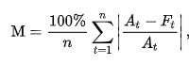

Where,

*At* is the actual value

*Ft* is the predicted value

**4.2 END NOTE**

We established significant relationship between several independent variable and Bike rental. We developed a regression model that can be applied to predict daily demand. and also found that the usage of bike rental is far higher for registered users as compared to causal user, also weather has significant effect on bike ridership, a clear and sunny weather invited more riders as compared to rainy and snow weather. We trained various different models and preformed. we can thus conclude that the developed model can be used to predict the bike demand on daily base

***APPENDIX – B***

***VARIANCE INFLATION FACTOR***

VIF (Variance Inflation Factor) is used to detect and remove multicollinearity. It is one of the assumptions of linear regression. VIF is used only on independent variable. It is calculated by the formula,

VIF = 1/1-r2

Where, r2 = % variance in variables & 1-r2 also called tolerance of the model.

If r2 is high it means the given variable is redundant. So we need not to bring the given variable in the model. It means the given variable is highly correlated. If r2 is low it means the given variable is not redundant and we should include that variable in our model. It means the given variable is less correlated.

Higher the VIF more collinear is the variable which means we should not include that variable in our model. Lower the VIF less collinear is the variable which means it can be included in our model.

***Basic Output Terms***

**Residual standard error:** It is also called standard deviation error. It measures the average amount that the coefficient estimates vary from actual average value of our response variable. It helps in calculation of p-value.

**t- value:** It measures how many standard deviations our coefficients are away from 0. Coefficients should be far away from zero because if coefficient of any variable is near to 0 it means that variable is not able to explain the target variable i.e. that variable is an irrelevant variable. With help of t-value we calculate p-value.

**p-value:** It helps us to decide whether to accept or reject the variable i.e. a variable is contributing much information or not.

**F-statistics:** It is a good indicator of whether there is a relationship between our predictor and the response variable. F-statistics should be greater than 1.

**Degrees of Freedom:** Number of observation (training data) – Total number of variable

**R Square:** It is numerical value which tells us the amount of variance of the dependent variable is explained by all independent variable. It tells us how much our model is robust and what the strength of model on training data is.

**Adjusted R Square:** It is derived from R-Square values. Adjusted R Square will penalize the effect of additional variables which are not carrying much information. It should be always less than R Square.

**AIC (Alkaline Information Criteria):** It adjusts the loc likelihood based on the number of observation and complexity of the model.

**BIC (Baisen Information Criteria):** It is similar to AIC but has high penalty for models.

**Omnibus:** Provides combined statistical test for the presence of skewness and kurtosis. Basically it is breakdown of skewness and kurtosis.

**Skew and Kurtosis:** These tests are basically for time series dataset.

**Null Deviance:** It tells us how well the response variable is predicted by the model with intercept only.

**Residual Deviance:** It tells us how well the response variable is predicted by using null deviance and all other independent variables.

***REFERENCE***

1. **“*Edwisor Videos”***
2. **Youtube**